  
  C. F. Martin & Co. has a long and distinguished history as one of the premier makers of acoustic guitars. And now, with the introduction of the 1-Series, we’ve made legendary Martin quality and tone even more affordable and irresistible.
  The 1-Series is available in your choice of a purely acoustic Dreadnought size D-1 and an Orchestra size OM-1. The DC-1E and OMC-1E acoustic-electric cutaway models feature true acoustic sound — plugged or unplugged.
  Visit your local authorized Martin dealer to see, hear and play the new Martin 1-Series instruments.
    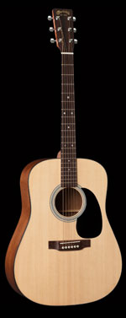
    D-1
    Detailed Views
    Top:
    Solid Sitka Spruce
    Back /Sides:
    Solid Sapele
    Fingerboard/Bridge:
    Solid East Indian Rosewood
    Full Specifications & List Price
    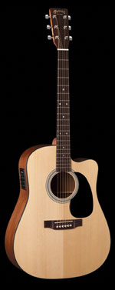
    DC-1E
    Detailed Views
    Top:
    Solid Sitka Spruce
    Back /Sides:
    Solid Sapele
    Fingerboard/Bridge:
    Solid East Indian Rosewood
    Electronic Features:
    Volume, Tone Shaping Controls, Onboard Digital Tuner, Pop-up Battery Access
    Full Specifications & List Price
    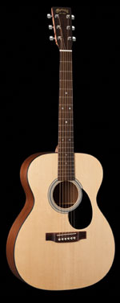
    OM-1
    Detailed Views
    Top:
    Solid Sitka Spruce
    Back /Sides:
    Solid Sapele
    Fingerboard/Bridge:
    Solid East Indian Rosewood
    Full Specifications & List Price
    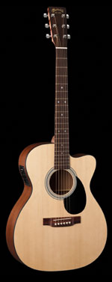
    OMC-1E
    Detailed Views
    Top:
    Solid Sitka Spruce
    Back /Sides:
    Solid Sapele
    Fingerboard/Bridge:
    Solid East Indian Rosewood
    Electronic Features:
    Volume, Tone Shaping Controls, Onboard Digital Tuner, Pop-up Battery Access
    Full Specifications & List Price

